2009 Cabernet Sauvignon

VARIETIES: | 100% Cab Sauv | 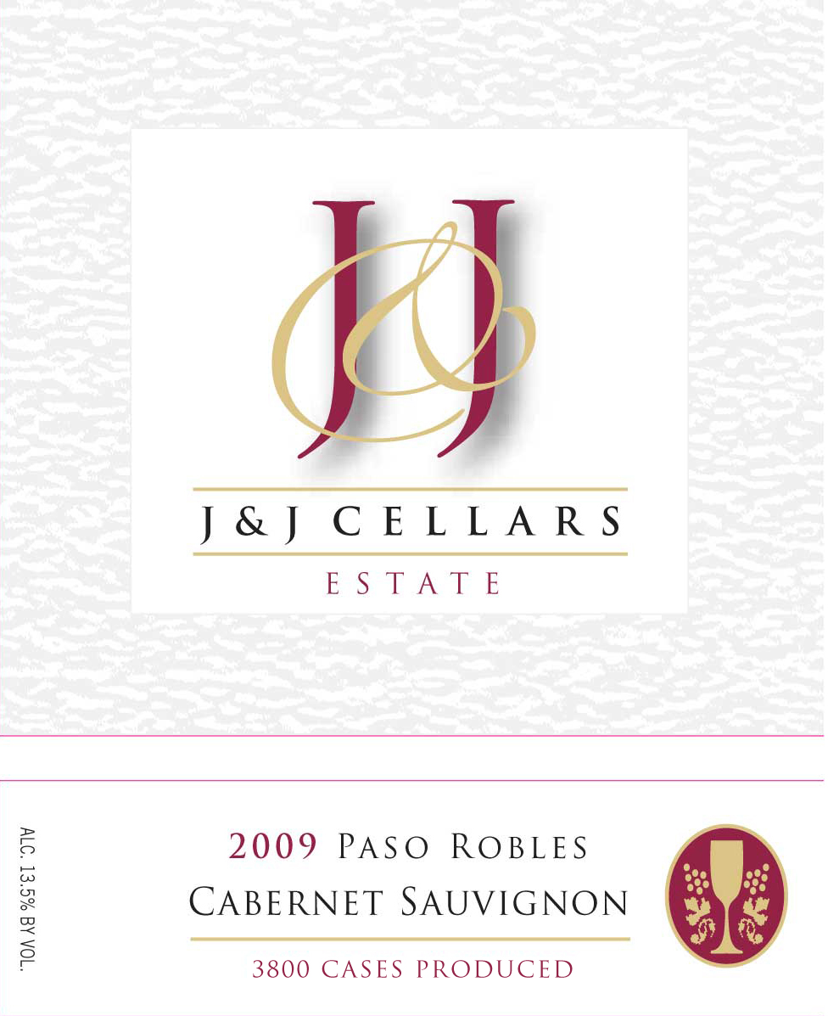
APPELLATION: | Paso Robles
VINEYARD: | San Miguel Estate
ALCOHOL: | 13.5%
ACIDITY: | 6.4g/L
pH: | 3.71
RESIDUAL SUGAR: | 0.03%
CASES PRODUCED: | 3800
GROWING CONDITIONS
The 2009 vintage began with average temperatures and slightly lower than normal winter rainfall. A late spring frost came in April and slowed vine growth. However, warmer temperatures returned in May. Aside from late rain in mid-October, the duration of the vintage was uniform leading to a long growing season. Harvest at J&J stretched from early September to late November. The longer hang-times allowed for optimal berry development. The resulting wines are deeply colored with significant tannic structure and powerful aromatic intensity.
WINEMAKING
Our grapes were harvested in the cool early morning hours and brought to the winery where they were de-stemmed and crushed into a stainless steel fermenter. After 24 hours, the must was inoculated and pumped over 2-3 times daily through the duration of primary fermentation. The grapes were pressed and upon completion of malolactic fermentation the wine was aged in a combination of French, American and Hungarian Oak, (30% new) for 11 months prior to bottling.
TASTING NOTES
Our Estate Cab has aromas and flavors of sweet raspberry, cherry, and toasty vanilla with full tannins and a lingering finish.
CELLARING
Enjoy now with decanting. Best cellared for 1-2 years and will continue to evolve beautifully during the next 4-6 years.
FOOD SELECTION
Hamburgers, steaks and tri-tip—this wine will work well with a variety of beef inspired meals.

